9 September 2026

Dear Students and Parents/Carers,

We are delighted to welcome all our students back to MER for the new academic year. We hope you have had a restful and enjoyable summer break.

As we begin this exciting new term, we are looking forward to a year filled with opportunity, growth, and success. Our school values – Determination, Respect, Excellence, Attitude, and Maturity – will continue to guide all that we do. These principles are not just words but the foundation of the positive, ambitious culture we strive to build together.

To help students start the year on the right foot, we ask for your continued support in ensuring that all students arrive each day in the correct school uniform, equipped with the necessary materials for learning, and wearing their updated school lanyard and passport (issued to them on the first day). These small but important details contribute to a calm, focused, and respectful school environment where students can thrive.

I would like to remind you of the letter we shared at the end of last academic year regarding uniform and mobile phone expectations. This can be accessed here. A key change to our expectations regarding mobile phones sanctions is detailed within this letter. For this half term students will be expected to show, during line ups, that their phones are turned off and placed into their bags. They should not be kept in blazer/trouser pockets. I have included a reminder of our new sanctions regarding mobile phones should a student be seen using theirs during the school day.

 | Sanction | Consequence for refusing to hand over the phone
1st offence in the year | The phone is taken from the student at the time of the offence.  A phone call / message is sent home to alert the parents of the confiscation.  The phone is kept until the end of the week in the school office.  The student attends an after-school detention on Friday and is given their phone back at the end of the detention. | The student is placed into Internal isolation until the phone is handed in.  If the student refuses isolation they will be suspended for defiance for the remainder of the day.  When the parent collects their child in order to serve the suspension, the phone must be handed to a member of staff.  The phone is kept in the school office until Friday and is handed back to the student after the Friday detention.
2nd offence in the year (and all further offences) | The phone is taken from the student at the time of the offence.  A phone call / message is sent home to alert the parents of the confiscation.  The phone is kept in the school office until the end of the half term.  The student sits a detention on the last day of the half term.  The parents come to school at the end of the detention to collect the phone and their child. | The student is placed into Internal isolation until the phone is handed in.  If the student refuses isolation they will be suspended for defiance for the remainder of the day.  When the parent collects their child in order to serve the suspension, the phone must be handed to a member of staff.  The phone is kept in the school office until the last day of the term and is handed back to the student after the Friday detention.

We are optimistic that all students will comply with these new expectations following the changes to government legislation regarding mobile phones in schools. We request your support in ensuring that all student are complying with uniform and mobile phone expectations.

I would also like to remind you of our equipment expectations for students to ensure they are Ready to Learn at all times.

Equipment required for students include:
- Black pen
- Green pen
- Pencil
- 15cm ruler
- Protractor
- Compass
- Scientific calculator – recommended Casio FX83GT or Casio FX85GT
- It would also be beneficial for students to bring a highlighter and small selection of coloured pencils; however, this is not compulsory.

In addition to the above a refillable water bottle is a required item for all students from September 2026. Students may bring their own bottle or purchase one from school for £2.

Year 11 Welcome

I would like to extend a warm welcome to all our Year 11 students and families as we begin what is undoubtedly one of the most important years in your child's education. Year 11 is a year of challenge, opportunity and achievement as students prepare for their GCSE examinations and take important steps towards their future destinations.

Throughout the year, our focus will be on ensuring every student is supported to achieve their full potential. Success in Year 11 is built through excellent attendance, positive attitudes to learning, effective revision habits and strong partnerships between school and home. We encourage parents and carers to play an active role in supporting their child and maintaining regular communication with us.

Year 11 can at times feel demanding for students, but it is also an exciting opportunity for them to demonstrate their growth, resilience and ambition. We are committed to supporting every student throughout their GCSE journey and look forward to celebrating their successes along the way.

The Team

The year 11 tutor team is one of the most fundamental components of the school partnership in ensuring that the students feel content and nurtured. I would like to remind you of the team as below:

Head of Year | Miss Ryan
G1 | Mr Brown & Mrs Trafford
G2 | Miss Nemeth & Ms Els
P1 | Miss Haveron
P2 | Mr Corner
T1 | Dr Diriyai & Miss Murphy
T2 | Miss Elahi

If your child has any problems or queries their tutor should be their first port of call. The tutor team prides itself on ensuring that everyone is working to the best of their ability and that your son/daughter is fulfilling the high expectations that Maiden Erlegh School in Reading prides itself upon.
We thank you for your ongoing partnership and support, and we are excited to work together to make this a successful and rewarding year.
Homework
While we encourage students to take responsibility for meeting deadlines and managing their time, a little parental help with planning at the beginning of the year would be most appreciated. As a school we set all homework using ClassCharts and Google
Classroom. Please ensure that you speak to your child about upcoming homework deadlines and support them in achieving these.
Attendance and Punctuality
I would like to take this opportunity to remind all parents and students of the importance of good attendance at school, as well as good punctuality to school and to all lessons. It is imperative that students arrive on time to school and are READY to make the most of their learning opportunities.
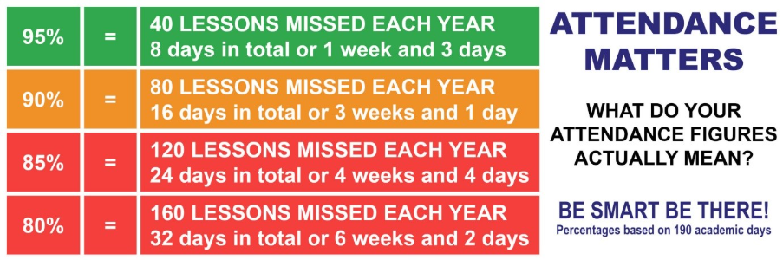
Key Dates for Year

There are a few important dates that you will need to be aware of and we ask that you avoid making appointments at these times.

Please make a note of the following important dates:
- Year 11 Parents' Information Evening – 16 September 2026
- PPE 1 (Pre-Public Examinations) – 19 October 2026 to 6 November 2026
- Year 11 Progress Meeting – 8 December 2026
- PPE 2 (Pre-Public Examinations) – 25 January 2027 to 3 February 2027
Further information regarding each event will be shared closer to the time.

I will also be sharing destinations information over the next few weeks, so please keep an eye out for that letter.

Finally, I am incredibly proud of the way in which the year group presented themselves at the beginning of this term. I look forward to working in partnership with you all to ensure an excellent experience of year 11 for your child. Please do not hesitate to contact me, via the school office.

Yours sincerely
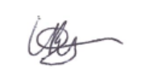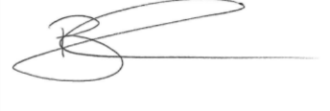
Miss L Ryan Head of YR 11 Miss B Davies AHT Behaviour & Culture

